**ITCS231**

**Data Structures and Algorithm Analysis**

**Programming Project 2**

Waris Damkham 6388014

Section 1

**Asst. Dr. Ananta Srisuphab**

**HashMap to generate the postcode**

Code:**

This program will read the text file but in this case, read the file name "TH.txt." In the text file name, "TH.txt" has a country, postcode, place, province, and latitude longitude. And a program will ask user input of how many times you want to generate the information. Next, it will ask you to input the place's name and then print out the postcode and more information about this place.

**The Output:**

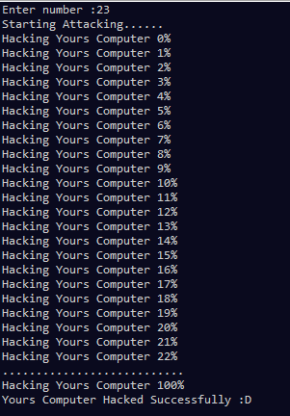

**Reference**

*Why String class is popular key in a HashMap in Java?* (n.d.). Tutorialspoint. Retrieved October 30, 2021, from <https://www.tutorialspoint.com/why-string-class-is-popular-key-in-a-hashmap-in-java>